

Sustaining and Training for Resilience, Engagement and Meaning Training Manual

Table of Contents

Contents

STREAM Facilitators Checklist 3

Planning for technology use 3

Technology used during STREAM sessions 4

Zoom Tips 4

Test presenting slides and videos 4

Plan for technology glitches 4

Planning for group facilitation 5

Reflect on the context including who is attending and any situational factors 5

Review learning objectives 5

Prepare your introduction. 5

Develop session participations guidelines 6

Preparing to facilitate 6

Post Presentation 6

Send attendance data to STREAM coordinators 6

Review evaluation data and plan improvement for the next session 6

Face to Face and Virtual Sessions 6

References 7

Introduction to STREAM …………………………………………………………………………………………………………………………8

STREAM activities list…………………………………………………………………………………………………………………………...15

STREAM Design Principles…………………………………………………………………………………………………………………….20

STREAM worksheets…………………………………………………………………………………………………………………………….22

STREAM Key References………………………………………………………………………………………………………………………56

STREAM presentation rubric…………………………………………………………………………………………………………….....68

# STREAM Facilitators Checklist

|  |  |  |
| --- | --- | --- |
|  | Planning to promote the session | Who |
|  | Set Date and email [STREAM@nationwidechildrens.org](mailto:STREAM@nationwidechildrens.org) with date and module |  |
|  | Determine modality (face to face, virtual, hybrid) |  |
|  | Reserve Space or Set up virtual meeting |  |
|  | E-mail announcement with link to register on the STREAM site |  |
|  | Create appointment in Outlook with all of the rooms, speakers (or have leader from groups complete) |  |
|  | **Planning for technology use** | **Who** |
|  | Test presenting slides and videos in the room or virtual meeting platform |  |
|  | Plan for technology glitches |  |
|  | **Preparing for group facilitation** | **Who** |
|  | Reflect on the context including who is attending and any situational factors |  |
|  | Review learning objectives |  |
|  | Review the flow of the session |  |
|  | Prepare your introduction |  |
|  | Develop session participations guidelines |  |
|  | Practice video introductions and debrief questions |  |
|  | Practice activity introductions and facilitation   * Communicate purpose of activity * Communicate assignments * Plan for interaction with participants during the activity * Prepare to debrief after the activity |  |
|  | **Planning the session Wrap up** | **Who** |
|  | Encourage reflection and planning of next steps |  |
|  | **Post Presentation** | **Who** |
|  | Send attendance data to STREAM (if you don’t use attendance QR code) |  |
|  | Review evaluation data and plan improvement for the next session |  |

# Planning for technology use

STREAM sessions leverage a few common educational technologies to deliver an effective and engaging program. The technologies used include PowerPoint presentations and video as well as Zoom in the case of virtual sessions. Planning for technology includes testing it in the venue where the session will take place and planning for what you will do if it fails during the session.

## Technology used during STREAM sessions

The format of the content for STREAM sessions is PowerPoint presentations and MP4 videos. Most personal and institutional systems are able to play content in these formats. Additionally, sessions may use audience response systems. Faciltators should use the audience response system supported by your institution. If you are presenting via Zoom, use the Polls feature for audience response questions. For more information on creating a Zoom poll visit <https://support.zoom.us/hc/en-us/articles/203749865>

### Zoom Tips

If your presentation will be virtual there are a few basic tips to improve the experience for your participants:

1. Make sure your audience can hear you. Test your mic before joining a Zoom meeting. Go Zoom Settings > Audio and test both your microphone and speakers.
2. Make sure your audience can see. Natural light is the best tool to look good in a virtual presentation. If the natural lighting isn’t an option, experiment with lamps – even a cheap ring light can make a huge difference.
3. If you have an unstable connection in the middle of a session, turn off your camera to save bandwidth. While it is not ideal, if participants can hear, you can still be effective.
4. To avoid a cluttered screen with static images and videos, you can hide meeting participants without video from the gallery view. Go to Settings > Video and click Hide non-video participants.
5. Hide your self-view during Zoom presentations. The self-view can be distracting. To avoid that, press the three dots button on your video and choose Hide Self View.
6. Eliminate notifications like messages or ads popping out when you’re sharing your screen. If you’re using a Mac, we recommend turning on Do Not Disturb mode, and for Windows users, use Focus Assist to avoid unnecessary pop-ups.
7. Encourage your audience to use reactions so they can respond and give feedback without unmuting or affecting meeting time

## Test presenting slides and videos (including audio)

To ensure that your presentation will run smoothly, test your slides and videos in the room (or zoom room) you will use on the day of the session. Make sure that all the videos launch and can be seen and heard by participants. Make sure that the system speakers are connected to the computer that is displaying the presentation. If using your laptop, plan extra time to get it connected to the room audio. It can be helpful to send the presentation and videos in advance to the technology support staff at your venue in case they need to make any adjustments to systems settings. The files are very large and may not be accommodated by email so you may have to find an alternate file sharing method.

## Plan for technology glitches

While the use of videos during presentations is common, so also are technology glitches that interrupt a presentation. To prepare for glitches, plan for what you will say or do in the following situations:

* What you can say or do while the problem is being fixed
* How you can summarize the video content so the learning can continue. Consider printing the slide deck so you have a hard copy to refer to.
* In light of the session objectives and flow, what can be modified in order to support learning and ensure the session ends on time.

# Planning for group facilitation

When preparing to facilitate a session, reflect on the context, learning objectives, and instructional methods. Considering the context and learning objectives can provide a broad perspective that will inform the detailed choices you make about the instructional methods.

## Reflect on the context including who is attending and any situational factors

Considering why sessions are being offered, who are the stakeholders and champions, and the needs of the participants can provide insight that will inform the choices you make about facilitation strategies. Reflect on the following questions:

* Why are STREAM sessions being offered?
  + What are the results of the program needs assessment
  + Who are the stakeholders and champions? Why do they support offering the program?
* Who will be attending?
* Why are they attending?
  + Are there situations or factors impact the need for the program?
  + Are there talking points or resources you want to make sure to include?

## 

## Review learning objectives

Reviewing the learning objectives for the session in light of the situational factors to determine how well they are aligned with the need for the program and the situational factors and if there are any modifications you need to make in the way you facilitate the session.

During a session, the facilitator’s specific roles typically include:

* Setting clear goals at the start of the session
* Facilitating the session and ensuring it runs on time
* Encouraging participants to ask questions throughout the session
* Clarifying areas that may cause misunderstanding or confusion

## Prepare your introduction.

The introduction of the session can influence the learning climate and promote psychological safety. Practice your introduction including:

* An overview of STREAM
* Introducing yourself and your interest in facilitating STREAM sessions
* Learning objectives
* Session Guidelines

### Develop session participations guidelines

Guidelines can foster an atmosphere of psychological safety, mutual respect, and collaborative inquiry. They help clarify expectations, cultivate a sense of belonging and the ability to engage productively.

The following are some suggestions for guidelines:

During this session we will be discussing some potentially sensitive issues. The following guidelines are designed to encourage safe and productive discussions.

1. Consider what participants share today to be confidential.
2. Listen respectfully.
3. Be open to hearing and learning from other perspectives.
4. Share responsibility for including all voices.
5. (If presenting virtually) Discussions are improved when participants can see non-verbal cues. If you can please keep your cameras on.

To help participants internalize the guidelines, wrap up the discussion of ground rules by asking if there are questions or suggestions for additional ground rules.

## Preparing to facilitate

* Practice video introductions and debrief question.
* Practice activity introductions and facilitation
* Plan the session Wrap up to encourage reflection and planning of next steps
* Utilize the facilitation rubric to remind yourself of good practice (last page of this document)

## Attendance

There is a QR code for participants on the title slide as well as the slide with the first activity to allow the opportunity to complete to those who were late or otherwise unable. If there are issues with the QR code, please utilize a paper sign in (for in-person) or put names in chat (virtual sessions) or other method of choice and then send the list of attendees to STREAM@nationwidechildrens.org.

# Post Presentation

## Reflect on presentation and plan improvement for the next session

Were there any unexpected questions, comments or something that didn’t go as planned? Anything you would like to change for next time? What can you share with the larger group to improve everyone’s success? We will share some of these ideas during our every-other-month STREAM faculty calls.

# Face to Face and Virtual Sessions

|  |  |  |
| --- | --- | --- |
| Active Learning Strategies | Face To Face | Virtual |
| Audience Response | Institutional supported system | Polls or Chat |
| Large Group Discussions | Participant discussions | Participant discussion or chat |
| Small Group Discussions | Table Groups | Break out rooms |
| Think-Pair-Share | Table groups | Break out rooms |
| Popcorn style reporting | Order by tables | Participants decide who reports next |

# References

[Guidelines for Discussing Difficult or High-Stakes Topics | CRLT (umich.edu)](https://crlt.umich.edu/publinks/generalguidelines)

Billings H, Malin T, Allen J, et al. Reimagining Learning Spaces of the Future: An Interprofessional, Virtual Workshop Utilizing Rapid Idea Generation and Lean Startup Methodologies. *MedEdPORTAL*. 2022;18:11217. Published 2022 Feb 11. doi:10.15766/mep_2374-8265.11217

Hurtubise L, Martin B, Gilliland A, Mahan J. To play or not to play: leveraging video in medical education. *J Grad Med Educ*. 2013;5(1):13-18. doi:10.4300/JGME-05-01-32

Hurtubise LC, Turner TL, Ledford CH, Mahan JD. Getting Started With Online Faculty Development. *J Grad Med Educ*. 2015;7(4):671-672. doi:10.4300/JGME-D-15-00415.1

Introduction

Those who practice medicine typically aspire to the positive aspects of the culture of medical humanism: striving to provide excellent care, adhering to ethical standards and contributing to the greater good. Unfortunately, necessary stressors, such as clinically and emotionally challenging patients, unpredictable workloads and documentation burden, and unnecessary stressors, such as difficult systems and teams threaten the persistence and wellness of even the most dedicated physicians. Recognition that multiple toxic characteristics of the medical culture are also contribute to distress and burnout in many individuals, including striving for perfectionism, an exaggerated sense of responsibility, self-criticism, suffering in silence and tending to work in isolation. The prevalence of extreme stress, burnout and more serious mental health concerns in physicians has been increased by the COVID-19 pandemic. In late 2022, pediatricians continue to be profoundly stressed due to the combination of pediatric COVID, atypical RSV and influenza, with pediatric hospitals reaching capacity even before the traditional cold-weather virus season. Burnout in physicians contribute to early retirement and attrition which will worsen the already anticipated shortfall of physicians by 2025. Burnout is a serious concern during residency where it affects between 39-74% of trainees and is associated with more medical errors and less effective care. Resident training is an important time to attend to mental health issues.

While multiple interventions targeting stress reduction and burnout in physicians have been developed and overall show promise, burnout rates in pediatricians has been rising for years even before the pandemic. Even with efforts to address systems issues to reduce distress, persistence of high levels of burnout imperil our health care system. STREAM is an interactive, skill building program to improve physician, clinician and trainee well-being. STREAM offers tools to improve individual and systems across four topics: Well-Being, Engagement, Resilience and Joy and Meaning.

The program is customizable:

Groups can choose 1 or more topics

All topics have a brief (60 min) and extended (90+ min) version

Longer versions have more time for activities and cover the topic more in-depth

All topics can be presented in-person or virtually

A main goal of this program is to be interactive (see design principles). Knowledge alone rarely supports behavior change. In that vein, we have developed an app to support STREAM colleagues in setting and meeting their personal goals related to STREAM topics.

All materials can be found on the website (<http://streamelms.com>). Once you create an account and login, there is a faculty resources tab where you can access the training manual, IRB materials, PowerPoint presentations, etc.

STREAM staff are willing to schedule a dress-rehearsal if you would like to practice before presenting. In addition, if you want to discuss a session or if there are unique circumstances at your site, STREAM leadership is available to support you. To schedule times, email Julie Young ([Julie.Young@nationwidechildrens.org](mailto:Julie.Young@nationwidechildrens.org))

**Well-Being**

Introduction:

This module focuses on optimizing your well-being and supporting your colleague’s well-being. Positive mental health is foundational to overall well-being. Like physical health, mental health can fluctuate depending on individual circumstances. The goal for this module is to help participants respect their mental health and help them create a supportive environment for their colleagues. Many people do not focus on their mental health until they are feeling very poorly. Participants are encouraged to be proactively attune to what things replenish and deplete them can help guide them in focus on themselves to prevent significant declines in well-being. In the same vein, brining awareness to the sometimes-subtle changes that occur when well-being is dropping can allow participants to adapt their attention to implementing well-being strategies before significant deleterious effects of poor mental health take hold. Also in this section, participants are guided to consider the best ways to support the wellness of their colleagues; creating a culture of caring can offset some of the negative aspects of medical culture such as perfectionism. In the longer version, time is taken to explore suicide in medical professionals, including risk and protective factors as well as providing the most up to date research on the subject.

Develop and implement a mental health well being plan and identify an accountability buddy or team

Know when and how to approach a colleague for whom you may be concerned

Discuss personalized, proactive strategies for optimizing mental health and protecting against suicide risk

Objectives:

1. Deepen our understanding of physician mental health and what factors of medical culture enhance risk
2. Commit to periodic reflection on mental health as a vital sign
3. Discuss personalized, proactive strategies for optimizing mental health and protect against suicide risk
4. Know when and how to approach a colleague for whom you are concerned
5. Develop and implement a well-being plan and identify an accountability buddy or team

Lesson plan:

Optimizing Well-Being

Introduction

PARTNER ACTIVITY: Positive/negative aspects of characteristics of those in medicine

Physician Mental Health & Distress: Reflection on Mental Health as a Vital Sign

Optimizing Mental Health Strategies

INDIVIDUAL ACTIVITY: Self- Compassion

INDIVIDUAL ACTIVITY: Gratitude

GROUP ACTIVITY: Incorporating gratitude at work

GROUP ACTIVITY: Cultivating a caring culture

PARTNER ACTIVITY: Relational Pauses

INDIVIDUAL ACTIVITY: Design a well-being plan

GROUP ACTIVITY: Well-being plan discussion

Summary and wrap up

Prioritizing Mental Health

Introduction

Continuum of Mental Health

PARNER ACTIVITY: Positive and Negative Aspects of Culture of Medicine

GROUP ACTIVITY: Mental Health as a Vital Sign

INDIVIDUAL ACTIVITY: Signals of Distress

Approaching a Colleague

GROUP ACTIVITY: Experience with Reaching Out

PARTNER ACTIVITY: Approaching a Colleague

GROUP ACTIVITY: Approaching a Colleague Wrap-up

Summary and wrap up

**Engagement**

Introduction

Engaging in improving one’s work increases job satisfaction, even in those who are burned out. A key element is collaborating with your team to drive positive changes as relationships and accomplishments are both important drivers of well-being. This section aims to remind people what it feels like to be engaged in problem-solving and to give them some space to begin thinking about how they can be more engaged in their work. This section is a little different than the others. For the 60-minute version, you will need to gather some information on work stressors that contribute to burnout from the group you are presenting before the training. You can create an anonymous poll (like survey monkey) and have the group leader send it out. Summarize the results/update water cooler (slides 17 and 18). Be prepared to discuss if there are any big differences between the typical stressors Suzie presents and the groups stressors. Update the engagement worksheet with cases to reflect the stressors of the group. (If you need some help with this, please email the project manager - julie.young@nationwidechildrens.org)

Objectives:

1. Appreciate relationship between physician engagement and overall wellness
2. Reflect on areas of personal importance in work that contribute to own/colleagues’ stress/burnout
3. Identify explicit ways to become involved in systems-improvement efforts in your own organization

Lesson Plan:

Introduction

PARTNER ACTIVITY: What is engagement

Background – what is engagement, why is it important

SMALL GROUP ACTIVITY: Identify your stressors

Empowering people to change their work environment

GROUP ACTIVITY: Examples of engagement in action

SMALL GROUPS ACTIVITY: Engagement in action

*Context in engagement

*PARTNER ACTIVITY: Personal reflection on engagement opportunities

Wrap up

*Only in 90-minute version

**Resilience**

Introduction: This section primarily on individual strategies to promote resilience. The materials are adapted from a curriculum called Flourish, which was developed by Jenny Reese. The 60-minute version covers thinking about total well-being, work life balance and using values to guide decisions. The 90-minute version also covers mindfulness and positive psychology interventions. For the 90-minute version, you will want to email out the flourishing ratio spreadsheet to participants ahead of time. As a backup, they can use the paper version on the worksheet, but they may need a few extra minutes to calculate their score. For both versions, it can be helpful to bring some crayons/markers/colored pencils for people to use when completing the PERMAH wheel. As a backup, you could ask to get some different colored highlighters from the unit.

Objectives:

1. *Identify the 6 facets of the PERMAH Model of Well-being.
2. *Apply the concept of well-being to your own life.
3. *Be acquainted with scope and scientific underpinnings of mindfulness and meditation
4. *Identify how to assess “mindfulness” for personal application
5. Understand role of Positive and Negative affect/emotion as normal processes within PERMAH Model of Well-Being
6. Practice exercises designed to cultivate positive emotion
7. Integrate valued directions as a guide toward balance and meaning in the PERMAH Well-Being Model

Lesson plan:

Introduction

*Total well-being

PARTNER ACTIVITY: Think of a time when you were at your best

PARTNER ACTIVITY: PERMAH coloring wheel

*Pragmatic mindfulness

*GROUP ACTIVITY: Short mindfulness activity

Positive Emotion

*INDIVIDUAL ACTIVITY: Flourishing Ratio

*GROUP ACTIVITY: Venting Discussion

*PARTNER ACTIVITY: What’s energizing you right now?

Values-based living

PARTNER ACTIVITY: What brings you joy/How do you want people to see you

INDIVIDUAL ACTIVITY: Values Bullseye

* In 90-minute version only

**Joy and Meaning**

Introduction: This section focuses on connecting with joy and meaning in medicine. Focusing and living your purpose improves your health. Leveraging positive colleague and patient relationships can cultivate joy. The skill for this session is reflective practice. The point of reflective practice is to ponder things that go well or things that go poorly to see how the story unfolded: How did your thoughts/feelings/behaviors influence the situation? What is something you want to make sure you do again (or not do again)? The one-hour sessions with either be on Meaning or Joy. The longer session will include both Meaning and Joy. In the 90-minute Joy and Meaning, the reflective practice on Joy will convert to a group discussion after the individual reflection (as opposed to a partner share).

Objectives:

1. Understand the importance of connecting with meaning
2. Connect with joy in medicine through positive relationships
3. Use reflective practice to deepen connection with joy and meaning

Lesson plan:

Meaning

Introduction

Why focus on meaning

PARTNER ACTIVITY: Reflect on meaning

How to focus on meaning

PARTNER ACTIVITY: Reflective practice/pair share

*PARTNER ACTIVITY: Ask and open and honest question

How to continue

Summary

Joy

Introduction

What is Joy

PARTNER ACTIVITY: What brings you joy

Relationships

PARTNER ACTIVITY: Reflect on positive relationships

How to continue

GROUP ACTIVITY: Making space for Joy

Summary

*Only in the 90-minute Joy and Meaning.

STREAM Activities

* Are only in 90 minute sessions

**Prioritizing Your Well-Being:**

1. Positive and negative aspects of culture of medicine
   * Objectives: Discuss three positive and three negative aspects with a partner
   * Debrief template: Slide has some common examples, ask if anyone wants to share others
2. Mental Health as a vital sign discussion
   * Objectives: discuss if mental health should count as a vital sign
   * Debrief template: Regardless of whether or not you think mental health truly counts as a vital sign, it is important to treat it the same as physical conditions (such as high blood pressure)
3. What are your signals of distress?

* Objective: self-reflect on personal triggers
* Debrief template: You will use this in your well-being plan

1. Experience with Reaching Out
   * Objectives: Recall times where people may have not seemed themselves, discuss if people felt comfortable reaching out and if they did how it went
   * Debrief template: It can feel uncomfortable to reach out to a colleague, especially if you do not have an especially close relationship. We are going to hear about some things that might make this easier from Dr. Moutier.
2. Approaching a Colleague

* Objectives: View a template of someone reaching out (RUOK video), practice vulnerability, identify key phrases to start/have uncomfortable conversations about mental health
* Debrief template: How did that feel?

1. Approaching a Colleague: Wrap up
   * Objectives: Discuss why it’s difficult to reach out to our colleagues about their mental health
   * Debrief template: If we work together, we can reduce the stigma around mental health and create a more supportive work environment.

**Optimizing Your Well-Being:**

1. Self-compassion

Objective: Think about self-talk and how you can shift that to be more compassionate

Debrief template: These changes can be small, but over time can make a big difference

1. Intentional gratitude & culture of gratitude
   * Objective: reflect on 3 questions related to gratitude, discuss how gratitude can be cultivated at work
   * Debrief template: What strategies have people tried? What is something you are interested in implementing?
2. Creating a culture of caring
   * Objective: Discussion about how to create a caring environment at work
   * Debrief template: What is a strategy you can implement?
3. Relational Pauses
   * Objective: Discuss how you have processed an impactful (positive or negative) event of yourself as a human
   * Debrief template: Many of you may have participated in formal debriefings. Relational pauses can have the same benefits and be more informal.
4. Well-being plan

* Objectives: self-reflect on well-being status, identify individual signs of distress, design well-being plan, brainstorm people who can help to hold you accountable
* Debrief template: What are some team-based strategies to improve well-being? How can you hold yourselves accountable as a team? Was anything difficult or surprising?

**Engagement:**

1. *Generating Stressors list (What are your stressors?)
   * Objectives: Generate list of things about work environment that contribute to poor well-being
   * Debrief template: Share ideas and prepare people to think about how they might make improvements
2. Other examples of engagement in action
   * Objectives: Participants begin thinking about what engagement includes
   * Debrief template: The slide has some examples to add to what the participants state
3. Engagement in action

* Objectives: generate action-oriented solutions for positive engagement, practice considering explicit steps for potential solutions, rate likelihood of leadership investment in potential solutions
* Debrief template: What was it like to try to come up with solutions? What was most difficult in this process? (emphasis on how different perspectives from a variety of people can allow for better/easier flowing solutions), Was this difficult or once you got in the flow did you find the work to be energizing?, emphasize that it can be a really positive process to get together with other thoughtful people and come up with ideas, Are these solutions practical?

1. *Personal engagement
   * Objectives: Allow people to start planning their own engagement to consider what stressor they might want to change, what people might want to work with them and who might sponsor the idea.
   * Debrief template: This was the start. Make a goal to continue.

**Resilience:**

1. Time you were at your best

* Objectives: identify key values (aspects of PERMAH) within the stories that you hear
* Debrief template: Share your story/what was that like to hear another person’s story of them at their best (“What were you doing? Who was around you? Where were you? What about that time made you at your best?), what are some of the attributes you heard in your colleagues stories?, overall very brief

1. PERMAH Coloring Wheel

* Objectives: self-reflect on various aspects of well-being, realize areas that need improvement/areas that are doing well, commit to specific actions to improve overall well-being
* Debrief template: anything surprising? Any observations/anything that you noticed? (don’t necessarily need to share details of wheel), what other areas do you want to devote a little more time to? What/when specifically can you do that?

1. *Steph Curry Video
   * Objective: Consider mindfulness in a chaotic environment
   * Debrief template: You can think about ways to incorporate mindfulness without going and sitting in a silent room
2. *Flourishing Positivity Ratio

* Objectives: self-reflect on your overall well-being
* Debrief template: No debrief

1. *Venting discussion
   * Objective: To discuss how to turn venting into a supportive conversation
   * Debrief template: We all need to have space to discuss things that aren’t going well. Make sure that we are cognizant about how negativity can impact others. Try to support colleagues when they are struggling with negative emotions.
2. Values Clarification
   * Objective: Pull out values you hear in other people’s stories
   * Debrief template: Think about what your partner heard as values that are important to you. You will have the opportunity to reflect on your values in the next exercise.
3. Values Bullseye

* Objectives: reconnect with your core values, identify what qualities you want to cultivate as a person, learn that your values are centered in your relationships with others
* Debrief template: What is important to you? Why did you choose this profession? What brings you joy and energy in work?

**Joy and Meaning**

1. Everyday meaning
   * Objective: Start to get people to focus on their meaning
   * Debrief template: We are going to spend more time connecting with our meaning shortly
2. Meaning Reflective Practice

* Objectives: recall key moments or events that made you reflect on your purpose, connect with others over your story
* Debrief template: What happened? How did the story unfold? What did you learn about what has meaning for you? Do you have any regrets looking back? Any thoughts about ways you can stay connected to what has meaning to you throughout the day? Act as the listener and keep trying to elicit important details out of those who share

1. Asking Open Questions
   * Objectives: Practice inviting people to reach deeper within their own thoughts
   * Debrief template: Asking open questions of yourself and others can help you connect more deeply with your meaning.
2. Reflect on a moment of positive connection with someone recently
   * Objective: Consider a positive connection in a relationship, share with a partner
   * Debrief template: We will have more time to think about joy shortly
3. Reflection on connecting with moments of joy

* Objectives: reflect on a meaningful connection with a patient or a colleague, connect with others over your story
* Debrief template: What were the joy moments of mutual delight?, Why was it meaningful to you?, What allowed you to experience that moment at that time (any specific mindset you were in, particular setting)? Surprises/insights? Relish in the joy of these stories and encourage the unique properties that come with each one. Use this time to really allow others to share their moments of joy.

1. *Making space for joy
   * Objectives: Discuss how to overcome our negativity bias
   * Debrief: We can change our brains to see the positive, but it does take work

**STREAM Design Principles:**

The following principles were based off feedback from evaluation forms completed by participants, responses to questions elicited from participants, speaking with participants, and evaluating content from the lens of stated program goals.

1. **We will aim to develop content that is 35-50% discussions/interactive activities.**

*Rationale:* Participants comment regularly that the interactive parts with their peers are the most valuable. As a main goal of STREAM is practicing/building skills, this is best accomplished through activities and active learning. We can add short videos on specific topics for those that want to learn more about the background/evidence and make these available to participants and all who visit our website as optional asynchronous activities.

1. **We will offer the format in both 90 minute 60 minute sessions for each pillar with the ability to mix and match pillar modules/content based on site needs.**

*Rationale:* Sites can choose which format fits best for specific groups. 1 hour sessions could easily be delivered in a departmental meeting and organized development times. Longer sessions could be delivered in a retreat, academic half-days, etc. The ability to customize content should increase ability for participants to engage in STREAM.

1. **We will focus on live events will an emphasis on presentations being delivered during scheduled departmental/divisional meetings (eg staff meetings, retreats, etc).**

*Rationale:* Participants’ comments strongly endorse the value of live sessions for interactivity with colleagues. This can be done virtually or in-person. We will not pursue asynchronous version due to these 3 deficits: 1. No connection with people; 2. Easy to play recording in the background/not actively engage with content; 3. Most of activities would need to be re-designed (and likely have a lower yield).

1. **We will develop content for a facilitator to lead rather than require STREAM sites to commit to developing content experts.**

*Rationale:* Site will struggle to produce individuals who can become subject matter experts. Our leadership team provides excellent content. Video clips will be re-recorded as needed for quality and dropped into slide decks for facilitators. Our training institute for year 2 will focus on training facilitators to use these slide decks (with different presentation options).

1. **We will incorporate explicit EDI content into each presentation.**

*Rationale:* Equity is foundational to promoting well-being. Feedback from evaluations consistently scored low on incorporating EDI into presentations. More intentional incorporation of EDI principles/content will help insure better delivery and training on this point of emphasis.

1. **We will highlight the evidence for topics**

*Rationale:* Physicians and trainees will see that STREAM is evidence-based and evidence-informed. We will review the most impactful evidence for each pillar as part of the didactic section of the presentation.

1. **We will introduce 1 skill in each domain and create additional content to reinforce the skills to be delivered through the app**

*Rationale:* Skill building is paramount for successful behavior change. While a 1 or 2-hour session may not allow participants to develop competency in the skill, the live presentations will introduce the skill and provide practical tips to allow participants to continue. Additional content/activities will help solidify the skill for participants.

1. **We will ground each presentation in the PERMA-H framework**

*Rationale:* We will frame each session as a part of PERMA-H to allow participants to visualize how each is connected to their well-being.



**Well-Being (for 60 and 90 minute)**

**Practice Session for Break Out Room-**

**Instructions:** Quickly determine roles. If 3 in break out room, one to assume role of **CONCERNED COLLEAGUE,** another of **POTENTIALLY STRUGGLING COLLEAGUE** and 3rd of **OBSERVER.** IF 2 in break out room, then assume roles as **CONCERNED COLLEAGUE** and **POTENTIALLY STRUGGLING COLLEAGUE.**

**PLEASE ONLY READ YOUR ROLE BELOW. YOU WILL HAVE A TOTAL OF 7 MINUTES TO PARTICIPATE IN THE ROLE AND THEN DEBRIEF. YOU WILL BE GIVEN A 2 MINUTE WARNING THROUGH THE BANNER MESSAGING WHEN YOU SHOULD HAVE STARTED THE DEBRIEFING PROCESS.**

**CONCERNED COLLEAGUE**

The goal of this role play is to express support, to practice active listening skills and assess if your colleague could benefit from mental health support/treatment.

You have always found your colleague to have a positive attitude, and be engaging. Over the past 2 weeks you have noticed that they seem to become frustrated more easily, have a more negative attitude towards staff and parents, and to spend more time alone.

Today on rounds when a parent expressed frustration to the team about how long the work up was taking for their child, your colleague walked out of the room saying, “I give up, nothing is good enough even though you try your best. I’ve had it.” You are concerned that they may be struggling and want to reach out and offer support and determine if there may be a more serious mental health concern going on.

You have invited him/her for coffee and are now meeting with him/her.

Here are some pointers from the Mental Health as a Vital Sign presentation:

Coffee chat conversation prompts:

*“I’m concerned because I noticed… and I’m here to support you.”*

*“I’d like to learn more about what you’ve been experiencing in order to be a supportive colleague to you.”*

*“When you say ___, it makes me wonder if you’ve had thoughts about ending your life.”*

*Remember:*

* You will not make someone suicidal by asking about suicidal thoughts.
* You might miss an opportunity to save someone’s life by not asking.

If you meet with some resistance or minimization. Perhaps remind your colleague that you are reaching out because you care about them, NOT because they are not performing well, and you mean this to be a safe, judgment-free zone.

Another approach is to share if you’ve received mental health support or treatment in the past to imply that it’s a sign of strength not weakness to get help, and that mental health concerns are important to address.

**POTENTIALLY STRUGGLING COLLEAGUE**

You have usually enjoyed your work as a pediatrician or pediatric resident, and are known to, have a positive attitude and to enjoy spending time with colleagues. 2 weeks ago your mother who had been diagnosed with breast cancer earlier this year and is receiving chemotherapy is currently in the hospital with pneumonia. She is in a different state and while your father and sibling are there, you feel conflicted because you are quite close to her and want to be there too. You haven’t shared this information with anyone at work.

You have noticed that over the past 2 weeks you are a bit shorter tempered and haven’t wanted to socialize with your colleagues. Today at the end of rounds, the mother of one of your patients expressed frustration with you and the team as it was taking longer than she had expected to have the work of her child. You walked out of the room stating, “I give up, nothing is good enough even though you try your best. I’ve had it.” You are struggling to keep it all together, having trouble sleeping and not feeling yourself.

One of your colleagues has now asked you to take a coffee break. You agree although all you want to do is get your work done.

* If he/she begins by asking you how you are, state you are fine and no worries. You are somewhat concerned that he/she is meeting with you because you aren’t doing your job effectively.
* If he/she gives more specific examples of why they are worried, be open to sharing some of your stressors, e.g. about your mom, or the changes you’ve noticed in your sleep, irritability etc. And be open to what they suggest to you.

**OBSERVER:**

Your role is to observe the encounter and jot down observations. At the end of the encounter, ask the CONCERNED COLLEAGUE what they thought went well, what were the challenges, then ask the POTENTIALLY STRUGGLING COLLEAGUE the same questions. Then end by sharing your observations/insights.

**Mental Health as a Vital Sign**

**Well-Being Plan**

1. **Self-reflect and identify your individual signals of distress**

* Examples: irritability, temper flares, withdrawal or isolation from others, anxiety, depression, sleep changes, Others?

WHAT ARE YOURS?

1. **Design your well-being plan**
2. Strategies when you note increasing signals of distress

1. Strategies for everyday to optimize and maintain mental health
2. **Who can you identify as your Accountability Buddy?**

** STREAM: Engagement 60 Min**

we’d greatly appreciate your use of this qr code to

record attendance for this HRSA funded program

**Work Stressors:**

**Engagement Case 1: Late Day Admissions**

The afternoons on the inpatient wards are increasingly busy, with many nursing calls, patient issues, and an additional stressor of frequent late admissions from subspecialty clinics. Progress notes must be completed each day, the midst of these other demands. This adversely affects evening handovers, and residents are consistently staying late to finish tasks and notes at the end of the workday. Faculty seeing patients in clinic, residents on the inpatient service, and nursing staff are frequently stressed by these admissions, and worry about errors due to so many conflicting responsibilities.

**Engagement Case 2: Lack of social work staff in outpatient clinics**

Your institution has identified diversity, equity, and inclusion as an important priority of the institution, and addressing health disparities in your patient population in particular. Many residents and faculty recognize the inequities that patient’s experience are due to social determinants of health, and that to address these inequities in a meaningful manner, it will take more attention and personnel devoted to these issues.

**Engagement Case 3: EHR Challenges**

Multiple groups have identified inefficiencies in the institution’s EHR as a major stressor and there seems to be some willingness from hospital leadership to help address this issue. While the challenge seems daunting, leadership has asked them for help in this concern.

**Engagement Case 4: Recruitment and Retention**

Your manager is concerned about maintaining adequate staffing. Your unit is consistently searching for physicians and clinical staff; as soon a position is filled, someone else leaves the department. This is causing frustration as people are having to spend more time training new employees and providing gap coverage in addition to their regular job responsibilities.

**Engagement Case 5: Teamwork Culture**

Your department has difficulty functioning as a high-performing team. There are several people who many describe as ‘difficult’ and there are small groups who don’t like working together. In order to keep clinical care running smoothly, management has generally separated people who have tenuous relationships. Management acknowledges the issue and recognizes that clinical care and the work environment would be enhanced if these issues were addressed and improved and is willing to work cooperatively to solve.

discuss options for equitable solutions to determine conference/vacation schedule

**For your case:**

Step 1: Choose a scribe

Step 2: Choose a spokesperson

Step 3: Consider 2 (or more) potential solutions to the issue presented.

Consider the explicit steps or action items needed to accomplish the solution.

Step 4: Be prepared to share with the larger group!

|  |  |  |  |  |
| --- | --- | --- | --- | --- |
| Possible Solution 1 | *On a scale of 1 (not invested at all) to 10 (very invested), how invested is my institution likely to be in this issue AND solution?* | Step 1 | Step 2 | Step 3 |
|  |  |  |  |  |

|  |  |  |  |  |
| --- | --- | --- | --- | --- |
| Possible Solution 2 | *On a scale of 1 (not invested at all) to 10 (very invested), how invested is my institution likely to be in this issue AND solution?* | Step 1 | Step 2 | Step 3 |
|  |  |  |  |  |

Individual Activity: Commitment for Engagement

Identify an action item(s) and **write 1-2 down**

|  |
| --- |
|  |

Thank You

We’re so glad you could be part of this program with us today. Thank you for your participation!

Please help us out by completing this 6 question evaluation today! We’d love your input re: Content relevancy, DEI incorporation, interactiveness of session, facilitator effectiveness, likelihood to recommend, and an open ended section for anything you’d

like to note.

You’ll receive a follow up survey in two weeks and six months.

We’d love your feedback!

Eval



Extra Resources Available to You

STREAM Resource Library

There are extra STREAM resources and activities available for your use on our site as well.  We have more videos, worksheets, and other links that you may find beneficial.  Check them out here:

note: these materials are available for anyone with a STREAM account

Resources



STREAM App

Download our app, available for free

Apple: Android:

 

Features

-Buddy chat (anonymous capability)

-Goal setting and tracking

-Journaling

-Links to extra STREAM resources on the app

-Opportunity to provide feedback for STREAM programming

Follow us on Twitter: STREAM@elms

** STREAM: Engagement**

we’d greatly appreciate your use of this qr code to

record attendance for this HRSA funded program

**Work Stressors:**

**Engagement Case 1: Late Day Admissions**

The afternoons on the inpatient wards are increasingly busy, with many nursing calls, patient issues, and an additional stressor of frequent late admissions from subspecialty clinics. Progress notes must be completed each day, the midst of these other demands. This adversely affects evening handovers, and residents are consistently staying late to finish tasks and notes at the end of the workday. Faculty seeing patients in clinic, residents on the inpatient service, and nursing staff are frequently stressed by these admissions, and worry about errors due to so many conflicting responsibilities.

**Engagement Case 2: Lack of social work staff in outpatient clinics**

Your institution has identified diversity, equity, and inclusion as an important priority of the institution, and addressing health disparities in your patient population in particular. Many residents and faculty recognize the inequities that patient’s experience are due to social determinants of health, and that to address these inequities in a meaningful manner, it will take more attention and personnel devoted to these issues.

**Engagement Case 3: EHR Challenges**

Multiple groups have identified inefficiencies in the institution’s EHR as a major stressor and there seems to be some willingness from hospital leadership to help address this issue. While the challenge seems daunting, leadership has asked them for help in this concern.

**Engagement Case 4: Recruitment and Retention**

Your manager is concerned about maintaining adequate staffing. Your unit is consistently searching for physicians and clinical staff; as soon a position is filled, someone else leaves the department. This is causing frustration as people are having to spend more time training new employees and providing gap coverage in addition to their regular job responsibilities.

**Engagement Case 5: Teamwork Culture**

Your department has difficulty functioning as a high-performing team. There are several people who many describe as ‘difficult’ and there are small groups who don’t like working together. In order to keep clinical care running smoothly, management has generally separated people who have tenuous relationships. Management acknowledges the issue and recognizes that clinical care and the work environment would be enhanced if these issues were addressed and improved and is willing to work cooperatively to solve.

discuss options for equitable solutions to determine conference/vacation schedule

**For your case:**

Step 1: Choose a scribe

Step 2: Choose a spokesperson

Step 3: Consider 2 (or more) potential solutions to the issue presented.

Consider the explicit steps or action items needed to accomplish the solution.

Step 4: Be prepared to share with the larger group!

|  |  |  |  |  |
| --- | --- | --- | --- | --- |
| Possible Solution 1 | *On a scale of 1 (not invested at all) to 10 (very invested), how invested is my institution likely to be in this issue AND solution?* | Step 1 | Step 2 | Step 3 |
|  |  |  |  |  |

|  |  |  |  |  |
| --- | --- | --- | --- | --- |
| Possible Solution 2 | *On a scale of 1 (not invested at all) to 10 (very invested), how invested is my institution likely to be in this issue AND solution?* | Step 1 | Step 2 | Step 3 |
|  |  |  |  |  |

|  |
| --- |
| An area for collaborating to improve your work  A few colleagues who could join you in this work  A potential sponsor for this project |

Individual Activity: Personal Engagement

Thank You

We’re so glad you could be part of this program with us today. Thank you for your participation!

Please help us out by completing this 6 question evaluation today! We’d love your input re: Content relevancy, DEI incorporation, interactiveness of session, facilitator effectiveness, likelihood to recommend, and an open ended section for anything you’d

like to note.

You’ll receive a follow up survey in two weeks and six months.

We’d love your feedback!

Eval



Extra Resources Available to You

STREAM Resource Library

There are extra STREAM resources and activities available for your use on our site as well.  We have more videos, worksheets, and other links that you may find beneficial.  Check them out here:

note: these materials are available for anyone with a STREAM account

Resources



STREAM App

Download our app, available for free

Apple: Android:

 

Features

-Buddy chat (anonymous capability)

-Goal setting and tracking

-Journaling

-Links to extra STREAM resources on the app

-Opportunity to provide feedback for STREAM programming

Follow us on Twitter: STREAM@elms



** STREAM: Resilience**

we’d greatly appreciate your use of this qr code to record attendance for this HRSA funded program



**Positive and Negative Emotions**



**Finding Your Values Compass Example Values**

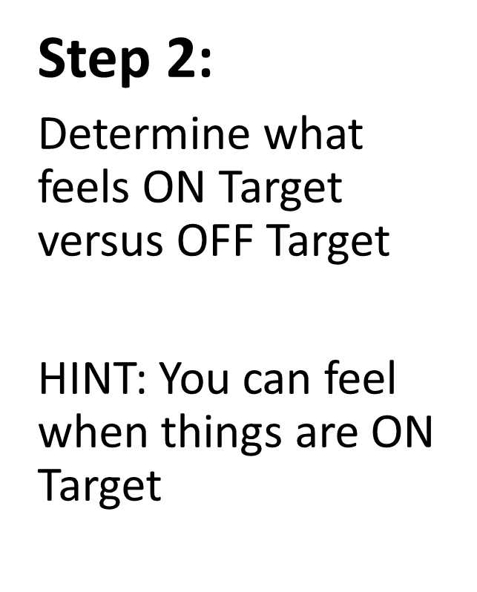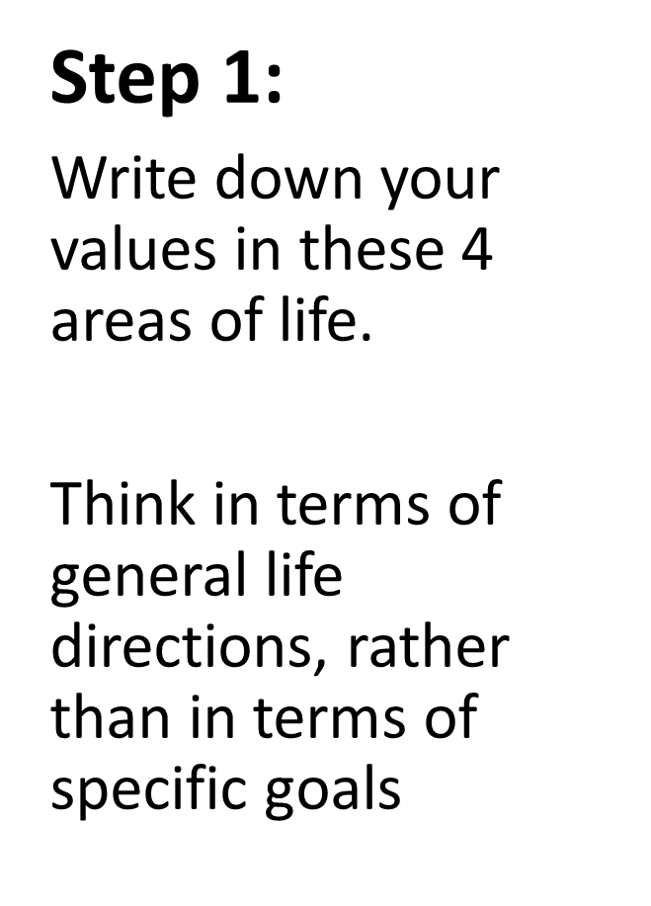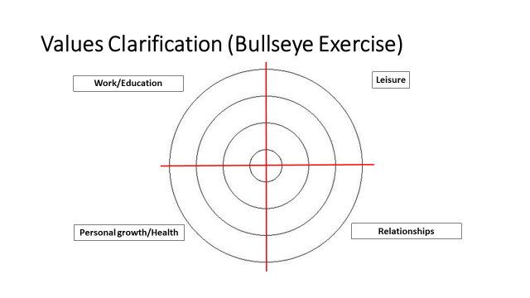

1.

2.

3.

4.

1.

2.

3.

4.

1.

2.

3.

4.

1.

2.

3.

4.

**Achievement**

**Adventure**

**Bravery**

**Authenticity**

**Compassion**

**Connection**

**Curiosity**

**Creativity**

**Dependability**

**Empathy**

**Equity**

**Honesty**

**Humor**

**Integrity**

**Joy**

**Leadership**

**Loyalty**

**Optimism**

**Peace**

**Respect**

**Responsibility**

**Service**

**Trust**

**Understanding**

**Wisdom**

Debrief: using values to assist in making decisions

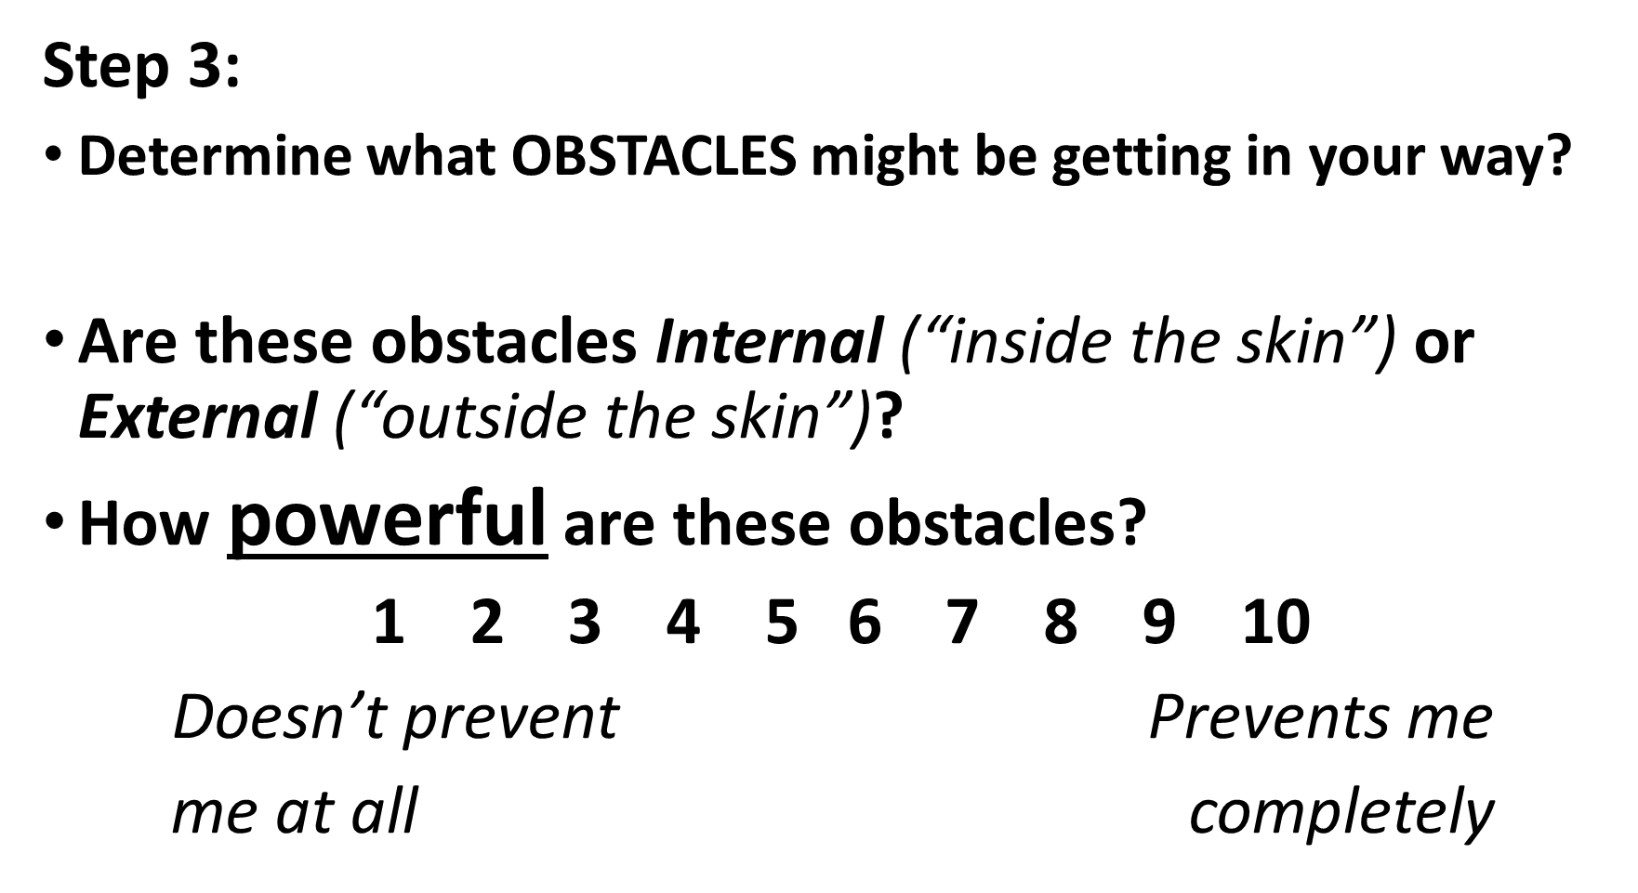

1 2 3 4 5 6 7 8 9 10

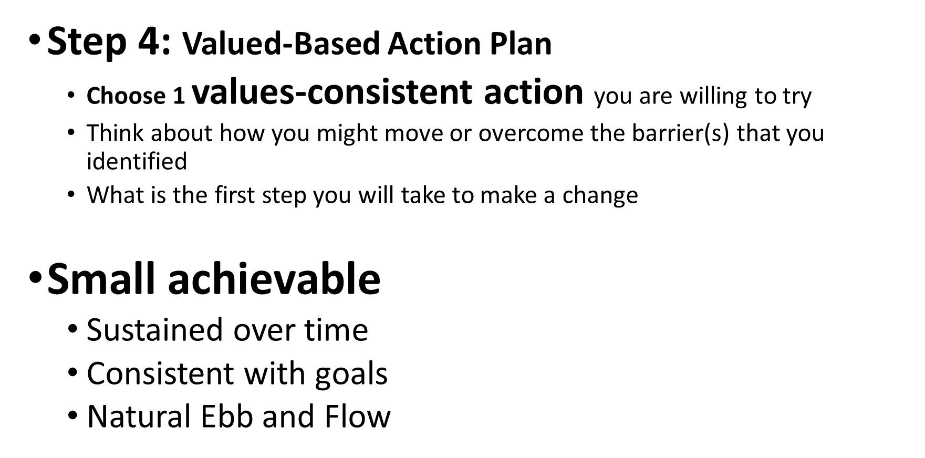

My values-consistent action is… ___________

The first step I will take to make a change is…

Thank You

We’re so glad you could be part of this program with us today. Thank you for your participation!

Please help us out by completing this 6 question evaluation today! We’d love your input re:

Content relevancy, DEI incorporation, interactiveness of session, facilitator effectiveness, likelihood to recommend, and an open ended section for anything you’d like to note.

You’ll receive a follow up survey in two weeks. We’d love your feedback!

Brief Eval



Extra Resources Available to You

STREAM Resource Library

There are extra STREAM resources and activities available for your use on our site as well.  We have more videos, worksheets, and other links that you may find beneficial.  Check them out here:

note: these materials are available for anyone with a STREAM account

Resources

 ****STREAM App

Download our app, available for free

Apple: Android:

 

Features

-Buddy chat (anonymous capability)

-Goal setting and tracking

-Journaling

-Links to extra STREAM resources on the app

Follow us on Twitter: STREAM@elms

**STREAM: Resilience**

we’d greatly appreciate your use of this qr code to record attendance for this HRSA funded program



1. **Introduction to Total Well-Being**

PARTNER ACTIVITY: listen for qualities you hear, no need to write

INDIVIDUAL ACTIVITY: PERMAH Wheel

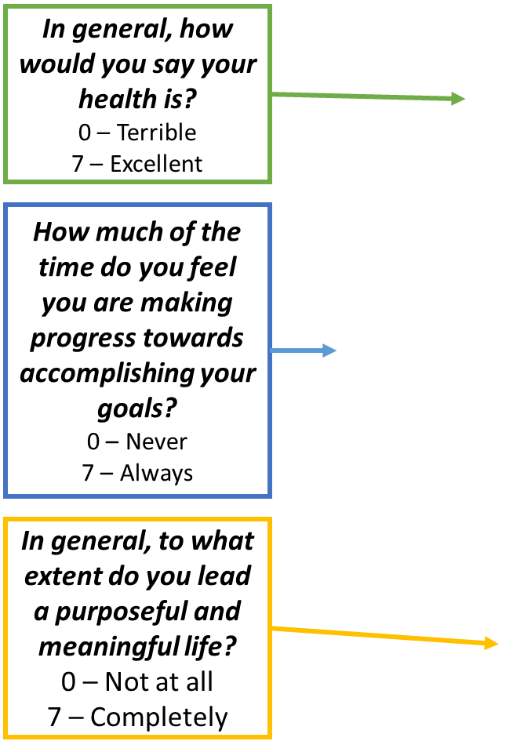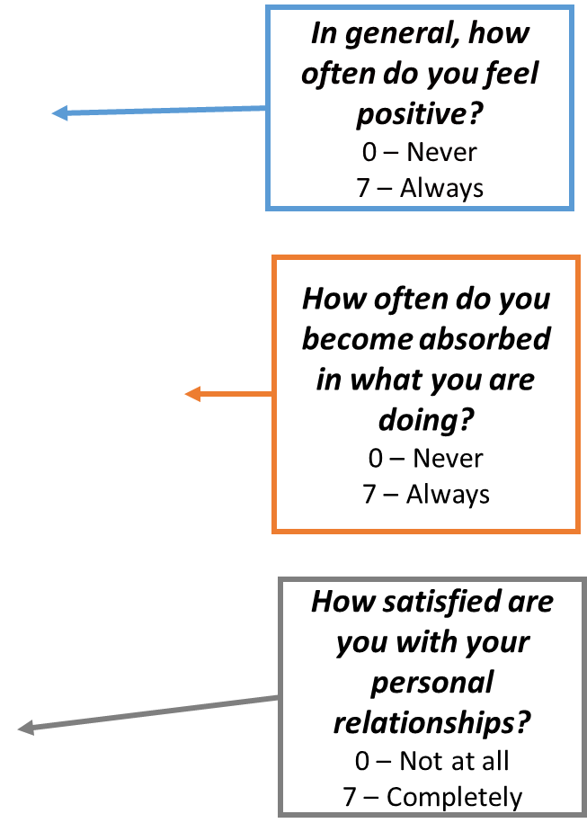 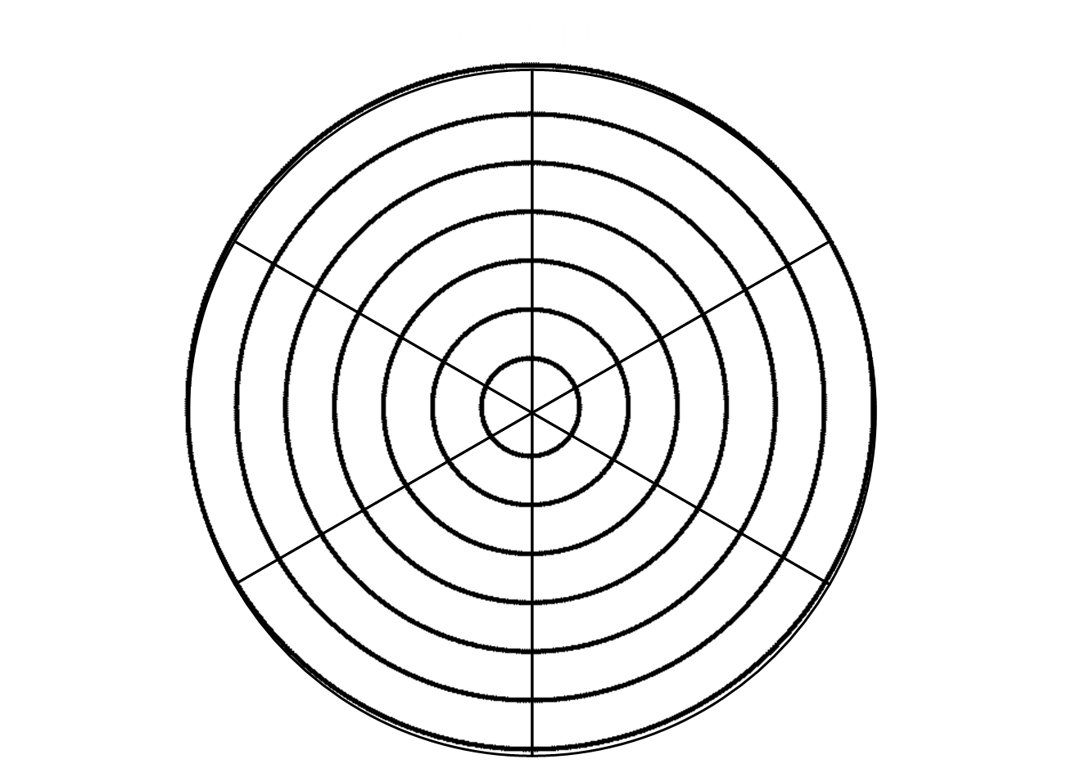

Reflection Discussion: did anything surprise you?

**What’s next?**

1. ***How much time*** do you have to devote to one or two of the above areas?

5-10 mins / 30 mins / 1 hour

1. ***What specifically*** would you be doing in one or two important domains?
2. ***When specifically*** can you do these things?

**2. Pragmatic Mindfulness**

INDIVIDUAL ACTIVITY: Cognitive Affective Mindfulness Scale Excerpt

Brief self-assessment – take a mental note

GROUP DISCUSSION: Steph Curry video

MINDFULNESS PRACTICE

**3. Positive and Negative Emotions**

INDIVIDUAL ACTIVITY: Flourishing ratio

Use the qr code to complete



GROUP ACTIVITY: Venting Discussion and debrief discussion

PARTNER ACTIVITY: active listening – 2 min each partner – what is energizing you? What are you doing to take care of yourself?

**4. Finding Your Values Compass**

PARTNER ACTIVITY

**Speaker questions to answer:** Why do you do the work that you do? What brings you energy and joy? Who do you most admire and why? What traits do you want to be known for? What do want to be said at your retirement party?

**Listener:** What values do you notice as you listen to your partner?

INDIVIDUAL ACTIVITY: Values Clarification

**Example Values**



1.

2.

3.

4.

1.

2.

3.

4.

1.

2.

3.

4.

1.

2.

3.

4.

**Ambition**

**Achievement**

**Adventure**

**Bravery**

**Authenticity**

**Community**

**Compassion**

**Competency**

**Connection**

**Curiosity**

**Creativity**

**Dependability**

**Empathy**

**Equity**

**Honesty**

**Humor**

**Integrity**

**Joy**

**Knowledge**

**Justice**

**Leadership**

**Loyalty**

**Optimism**

**Peace**

**Punctionality**

**Respect**

**Responsibility**

**Service**

**Trust**

**Understanding**

**Wisdom**

Debrief: using values to assist in making decisions



1 2 3 4 5 6 7 8 9 10



My values-consistent action is… ___________

The first step I will take to make a change is…

Thank You

We’re so glad you could be part of this program with us today. Thank you for your participation!

Please help us out by completing this 6 question evaluation today! We’d love your input re:

Content relevancy, DEI incorporation, interactiveness of session, facilitator effectiveness, likelihood to recommend, and an open ended section for anything you’d like to note.

You’ll receive a follow up survey in two weeks. We’d love your feedback!

Brief Eval



Extra Resources Available to You

STREAM Resource Library

There are extra STREAM resources and activities available for your use on our site as well.  We have more videos, worksheets, and other links that you may find beneficial.  Check them out here:

note: these materials are available for anyone with a STREAM account

Resources



STREAM App

Download our app, available for free

Apple: Android:

 

Features

-Buddy chat (anonymous capability)

-Goal setting and tracking

-Journaling

Follow us on Twitter: STREAM@elms

** STREAM:**

**Meaning**

we’d greatly appreciate your use of this qr code to record attendance for this HRSA funded program



**1. Why Focus on Meaning, 2, How to Focus on Meaning, 3. Stories of Meaning**

Listening sections, no need to write

**4. Reflective Practice as a Tool**

PARTNER ACTIVITY: Reflect/Pair Share

As you look back on your life, try to recall key moments or events that helped you develop a deeper understanding of your purpose.  These might be influential teachers or readings, opportunities that were offered or denied to you, doors that opened or closed, decisions you made or did not make, tough challenges or exciting realizations.

Take a few minutes to remember one of these moments.

What happened?  How did the story unfold?

What did you learn about what has meaning for you?

LARGE GROUP DEBRIEF

**5. Asking Open and Honest Questions**

PARTNER ACTIVITY: ask your partner a question to help them go deeper into meaning

**6. How to Continue this work**

In your day-to-day life, what can you do to notice the events that have meaning for you?

What are the clues that let you know you have made that connection?

Thank You

We’re so glad you could be part of this program with us today. Thank you for your

participation! Please help us out by completing this 6 question evaluation today! We’d love your input re:

Content relevancy, DEI incorporation, interactiveness of session, facilitator effectiveness, likelihood to recommend, and an open ended section for anything you’d like to note.

You’ll receive a follow up survey in two weeks. We’d love your feedback!



Extra Resources Available to You

STREAM Resource Library

There are extra STREAM resources and activities available for your use on our site as well.  We have more videos, worksheets, and other links that you may find beneficial.  Check them out here:

note: these materials are available for anyone with a STREAM account



STREAM App

Download our app, available for free

Apple: Android:

 

Features

-Buddy chat (anonymous capability)

-Goal setting and tracking

-Journaling

-Links to extra STREAM resources on the app

-Opportunity to provide feedback for STREAM programming

Follow us on Twitter: STREAM@elms

** STREAM:**

**Joy**

we’d greatly appreciate your use of this qr code to record attendance for this HRSA funded program



**Reflect on a moment of positive connection with someone recently**

Think about who you shared that moment with and what made it joyful.

What is one word that describes the feeling of that connection?

**1. Positive Impact of Joy**

PARTNER ACTIVITY: Reflection on connecting with moments of joy

**Reflect on a meaningful connection with a patient or colleague**

What were the joy moments of “mutual delight” you shared?

Why was it meaningful to you?

What allowed you to experience that connection at that time (e.g., setting, your frame of mind)?

GROUP DEBRIEF

**2. Continuing with Joy**

GROUP ACTIVITY: Making space for Joy

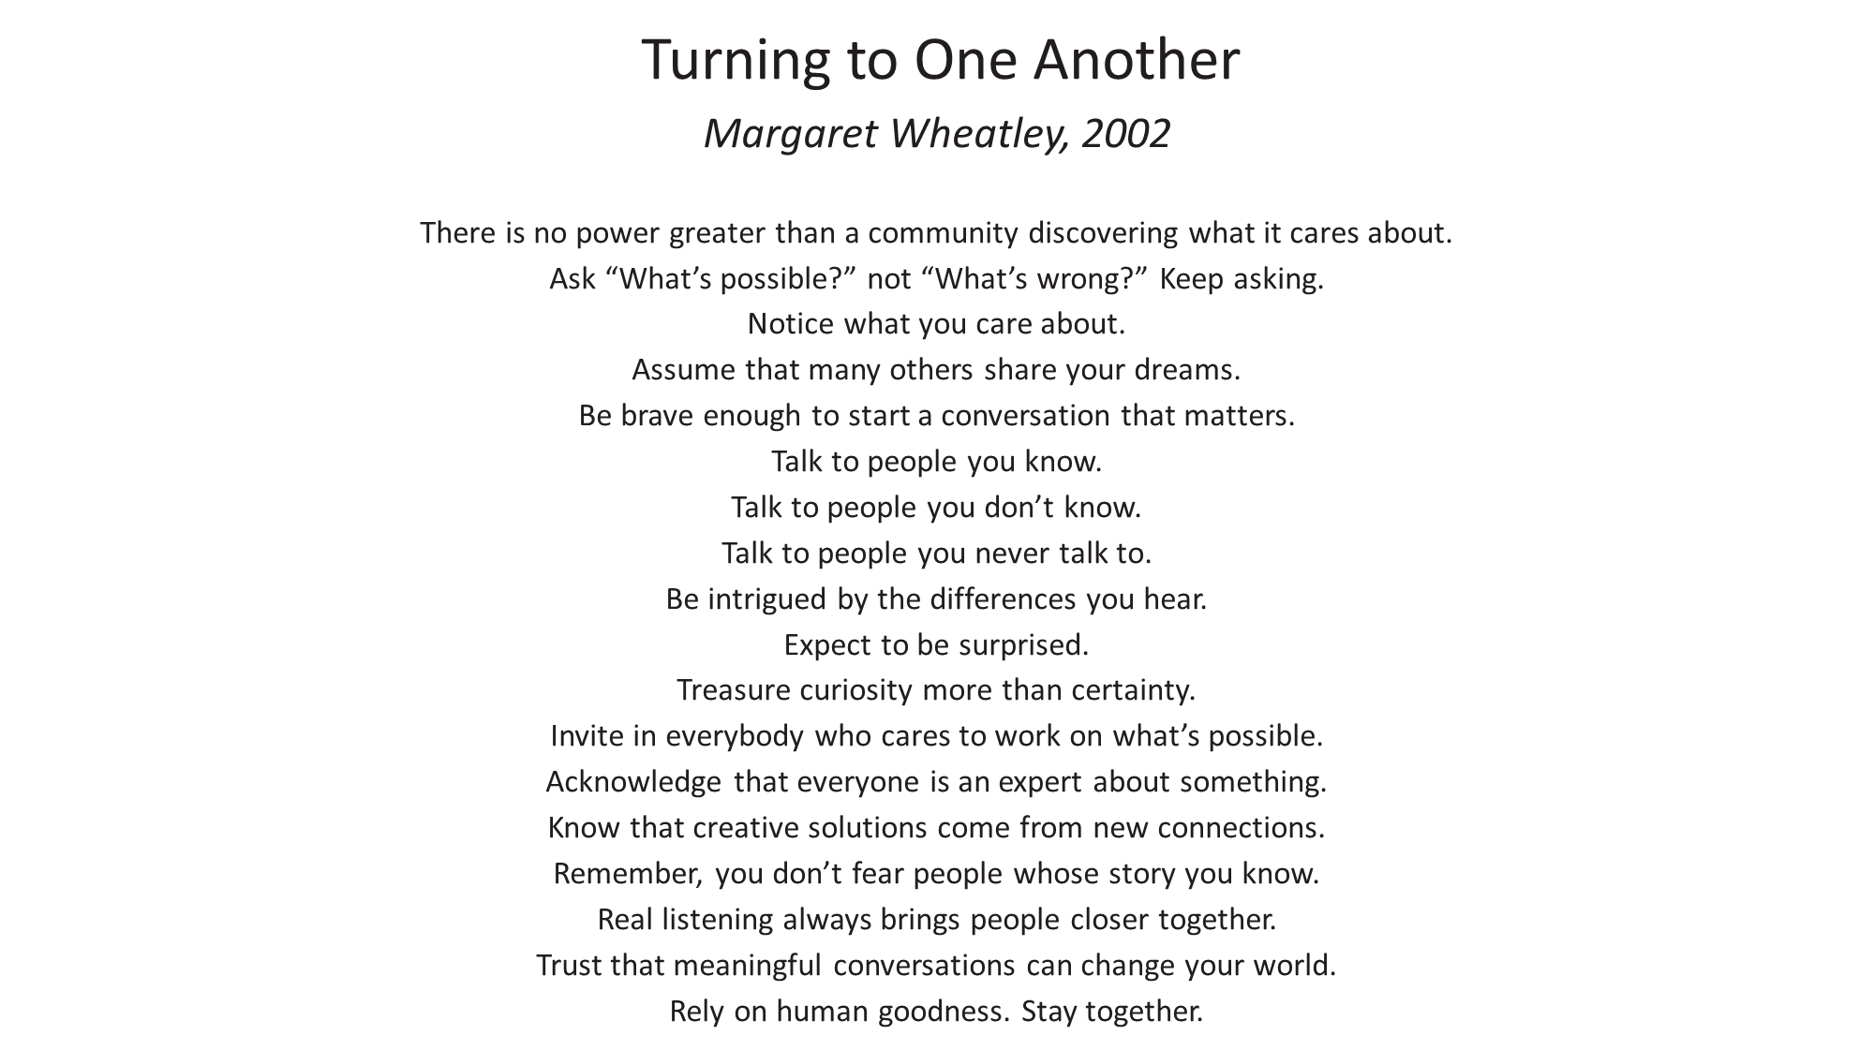

Thank You

We’re so glad you could be part of this program with us today. Thank you for your

participation! Please help us out by completing this 6 question evaluation today! We’d love your input re:

Content relevancy, DEI incorporation, interactiveness of session, facilitator effectiveness, likelihood to recommend, and an open ended section for anything you’d like to note.

You’ll receive a follow up survey in two weeks. We’d love your feedback!



Extra Resources Available to You

STREAM Resource Library

There are extra STREAM resources and activities available for your use on our site as well.  We have more videos, worksheets, and other links that you may find beneficial.  Check them out here:

note: these materials are available for anyone with a STREAM account



STREAM App

Download our app, available for free

Apple: Android:

 

Features

-Buddy chat (anonymous capability)

-Goal setting and tracking

-Journaling

-Links to extra STREAM resources on the app

-Opportunity to provide feedback for STREAM programming

Follow us on Twitter: STREAM@elms

** STREAM:**

**Joy and Meaning**

we’d greatly appreciate your use of this qr code to record attendance for this HRSA funded program



**1. Why Focus on Meaning, 2. How to Focus on Meaning, 3. Stories of Meaning**

Listening sections, no need to write

**4. Reflecive Practice as a Tool**

PARTNER ACTIVITY: Reflect/Pair Share

**Question:**

As you look back on your life, try to recall key moments or events that helped you develop a deeper understanding of your purpose.  These might be influential teachers or readings, opportunities that were offered or denied to you, doors that opened or closed, decisions you made or did not make, tough challenges or exciting realizations.

**Take a few minutes to remember one of these moments.**

What happened?  How did the story unfold?

What did you learn about what has meaning for you?

LARGE GROUP DEBRIEF

**5. How to Continue this Work**

PARTNER ACTIVITY: Reflect

**Reflect on a moment of positive connection with someone recently**

Think about who you shared that moment with and what made it joyful.

What is one word that describes the feeling of that connection?

**6. Positive Impact of Joy**

INDIVIDUAL ACTIVITY: Reflection

**Reflect on a meaningful connection with a patient or colleague**

What were the joy moments of “mutual delight” you shared?

Why was it meaningful to you?

What allowed you to experience that connection at that time (e.g., setting, your frame of mind)?

DEBRIEF

**7. Continuing with Joy**

GROUP ACTIVITY: Making Space for Joy



Thank You

We’re so glad you could be part of this program with us today. Thank you for your

participation! Please help us out by completing this 6 question evaluation today! We’d love your input re:

Content relevancy, DEI incorporation, interactiveness of session, facilitator effectiveness, likelihood to recommend, and an open ended section for anything you’d like to note.

You’ll receive a follow up survey in two weeks. We’d love your feedback!



Extra Resources Available to You

STREAM Resource Library

There are extra STREAM resources and activities available for your use on our site as well.  We have more videos, worksheets, and other links that you may find beneficial.  Check them out here:

note: these materials are available for anyone with a STREAM account



STREAM App

Download our app, available for free

Apple: Android:

 

Features

-Buddy chat (anonymous capability)

-Goal setting and tracking

-Journaling

-Links to extra STREAM resources on the app

-Opportunity to provide feedback for STREAM programming

Follow us on Twitter: STREAM@elms

KEY RESOURCES

The purpose of these resources is to give you some background material related to each pillar so that you are more familiar with each topic. The links to articles and references will take you to the source document.

Well-Being

**Cultivating the joy of medicine: A focus on intrinsic factors and the meaning of our work**

*Serwint*

Abstract

Physician burnout is at epidemic levels. In our role as healers, the concepts of humanism and relief of suffering are central themes in our work, yet burnout and depersonalization can threaten these values. While working to mitigate burnout, we need to move towards a focus on health and well-being and develop preventive strategies to cultivate resilience. This manuscript discusses the intrinsic factors that motivate us to be physicians: medicine as a calling, finding meaning in our work, and seeking joy in practice. Some strategies that enhance our resilience will be discussed including individual reflective practices, in addition to organizational strategies such as creating team mission statements, and participating in debriefing, Balint groups, and Schwartz Rounds. All of these practices provide opportunities to acknowledge the emotional impact of our care of patients and to focus on our values and the meaning of our work. Strategies to cultivate joy in practice are presented alongside a framework from the Institute for Healthcare Improvement to guide organizations.

[Cultivating the joy of medicine: A focus on intrinsic factors and the meaning of our work - PubMed (nih.gov)](https://pubmed.ncbi.nlm.nih.gov/31582295/)

Key Points

1. Journeying with patients through their suffering is one of the most rewarding privileges of our vocation, yet it can also be the source of our own suffering if there are not adequate opportunities to reflect on, process, and seek the support of colleagues around these challenging experiences.
2. A sense of calling is still a motivating factor for many who enter the medical field and this sense of calling must be protected and preserved for the benefit of both physicians and their patients.
3. Humanism is foundational to the practice of medicine and may protect physicians from burnout. Both intrinsic and organizational factors play a role in sustaining humanism and enhancing a sense of calling and purpose for health care professionals. A return to joy in medicine is essential to sustain individual physicians over the career span and to ensure the health of the medical profession as a whole.

**Implementing Emotional Debriefing in Pediatric Clinical Education**

*Osta et al*

Abstract

Challenging situations and intense emotions are inherent to clinical practice. Failure to address these emotions has been associated with health care provider burnout. One way to combat this burnout and increase resilience is participation in emotional debriefing. Although there are many models of emotional debriefings, these are not commonly performed in clinical practice. We provide a guide for implementing emotional debriefing training utilizing the American Academy of Pediatrics Resilience Curriculum into clinical training programs, with a focus on preparing senior residents and fellows to act as debriefing facilitators. Senior residents and fellows can provide in-the-moment emotional debriefing which allows for greater health care provider participation, including medical students and other pediatric trainees. Training of senior residents and fellows may allow more frequent emotional debriefing and in turn may help to improve the resilience of pediatricians when they face challenging situations in clinical practice.

[Implementing Emotional Debriefing in Pediatric Clinical Education - PubMed (nih.gov)](https://pubmed.ncbi.nlm.nih.gov/30343057/)

Key Points

1. Multiple studies demonstrate that emotional debriefing can reduce medical provider burnout and promote resilience. 1,11−13 Bateman et al13 reported that Wrap-ups, which included multidisciplinary debriefing after a pediatric patient death, alleviated the stress of providers involved.

**The AAP Resilience in the Face of Grief and Loss Curriculum**

*Serwint et al*

Abstract

A career in pediatrics can bring great joy and satisfaction. It can also be challenging and lead some providers to manifest burnout and depression. A curriculum designed to help pediatric health providers acquire resilience and adaptive skills may be a key element in transforming times of anxiety and grief into rewarding professional experiences. The need for this curriculum was identified by the American Academy of Pediatrics Section on Medical Students, Residents and Fellowship Trainees. A working group of educators developed this curriculum to address the professional attitudes, knowledge, and skills essential to thrive despite the many stressors inevitable in clinical care. Fourteen modules incorporating adult learning theory were developed. The first 2 sections of the curriculum address the knowledge and skills to approach disclosure of life-altering diagnoses, and the second 2 sections focus on the provider's responses to difficult patient care experiences and their needs to develop strategies to maintain their own well-being. This curriculum addresses the intellectual and emotional characteristics patient care medical professionals need to provide high-quality, compassionate care while also addressing active and intentional ways to maintain personal wellness and resilience.

Key Points

1. This role demands self-reflection, including the ability to deal with change, empathize with patients and families, and accept fallibility. To maintain resilience, it is essential to have exposure to strategies to recognize these risks and incorporate programmatic and individual strategies for wellness

[The AAP Resilience in the Face of Grief and Loss Curriculum - PubMed (nih.gov)](https://pubmed.ncbi.nlm.nih.gov/27940771/)

[Resilience Curriculum: Resilience in the face of grief and loss (aap.org)](https://www.aap.org/en/learning/resilience-curriculum-resilience-in-the-face-of-grief-and-loss/)

Engagement

**Physician Burnout, Engagement and Career Satisfaction in a Large Academic Medical Practice**

*Rao et al*

Abstract

**Objective**: To determine (1) if engagement among physicians impacted plans to stay in current role and job satisfaction, (2) what factors impact engagement and burnout, and (3) the relationship between engagement and burnout. Burnout has been described as a syndrome characterized by depersonalization, emotional exhaustion, and a sense of low personal accomplishment resulting in decreased effectiveness at work. Engagement may be regarded as the antonym to burnout and has been described as a connection to one's work characterized by dedication, vigor, and absorption.

**Design:** We extracted data from an academic practice-wide survey conducted at two time-points and evaluated physician burnout and engagement. We used the Maslach Burnout Inventory and the Utrecht Work Engagement Scale to evaluate the association between burnout and engagement and the impact of engagement on mitigating the effect of burnout in a large physician academic faculty practice.

**Setting:** Large academic practice PARTICIPANTS: Academic physicians METHODS: The authors conducted a hospital-wide physician practice survey in 2014 and 2017 assessing physician burnout and engagement.

**Results:** Of eligible physicians (n=1882), 92.0% completed a survey. High levels of engagement and burnout were shown in 59.5% and 45.6%, respectively. Compared to physicians with high levels of engagement and low levels of burnout, physicians with low engagement and low burnout were less satisfied with their career (OR=0.20, 95% CI=0.11-0.35) and less likely to stay in their current role (OR=0.52, 95% CI= 0.37-0.73). Among physicians with high levels of burnout, highly engaged physicians were more satisfied (OR=0.21; 95% CI=0.12-0.36 vs OR=0.08; 95% CI=0.05-0.12) and more likely to stay in their career (OR=0.34; 95% CI=0.25-0.45 vs OR=0.27; 95% CI=0.21-0.34) than non-engaged physicians.

**Conclusion:** Engaged physicians have higher career satisfaction. There are many actionable ways to improve engagement.

[Physician Burnout, Engagement and Career Satisfaction in a Large Academic Medical Practice - PubMed (nih.gov)](https://pubmed.ncbi.nlm.nih.gov/31959669/)

Key Points

1. We found that engaged physicians at our organization, regardless of their level of burnout, have higher levels of career satisfaction and are more likely to stay in their current role.
2. Although physicians with low levels of burnout and low levels of engagement fared better than those who were burned out, physicians who were not burned out but reported high levels of engagement were twice as satisfied with their careers as those with low levels of both burnout and engagement

**Executive Leadership and Physician Well-being: Nine Organizational Strategies to Promote Engagement and Reduce Burnout**

*Shanafelt*

Abstract

These are challenging times for health care executives. The health care field is experiencing unprecedented changes that threaten the survival of many health care organizations. To successfully navigate these challenges, health care executives need committed and productive physicians working in collaboration with organization leaders. Unfortunately, national studies suggest that at least 50% of US physicians are experiencing professional burnout, indicating that most executives face this challenge with a disillusioned physician workforce. Burnout is a syndrome characterized by exhaustion, cynicism, and reduced effectiveness. Physician burnout has been shown to influence quality of care, patient safety, physician turnover, and patient satisfaction. Although burnout is a system issue, most institutions operate under the erroneous framework that burnout and professional satisfaction are solely the responsibility of the individual physician. Engagement is the positive antithesis of burnout and is characterized by vigor, dedication, and absorption in work. There is a strong business case for organizations to invest in efforts to reduce physician burnout and promote engagement. Herein, we summarize 9 organizational strategies to promote physician engagement and describe how we have operationalized some of these approaches at Mayo Clinic. Our experience demonstrates that deliberate, sustained, and comprehensive efforts by the organization to reduce burnout and promote engagement can make a difference. Many effective interventions are relatively inexpensive, and small investments can have a large impact. Leadership and sustained attention from the highest level of the organization are the keys to making progress.

[Executive Leadership and Physician Well-being: Nine Organizational Strategies to Promote Engagement and Reduce Burnout - PubMed (nih.gov)](https://pubmed.ncbi.nlm.nih.gov/27871627/)

Key Points

1. Physicians were considered ‘engaged’ if they scored high on two of three subscales: vigor, dedication, and absorption.

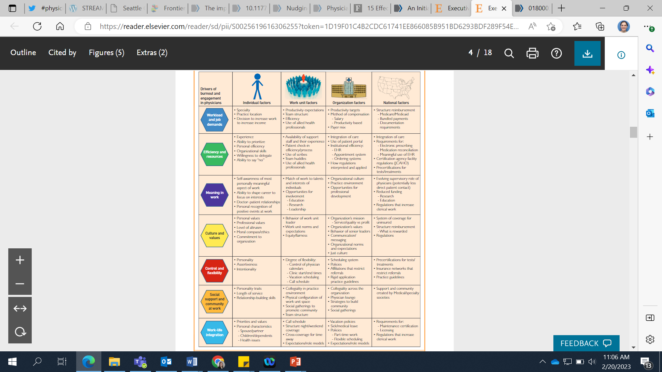

**An Initiative to Increase Residency Program Diversity**

*Hoff et al*

Abstract

A physician workforce that reflects the patient population is associated with improved patient outcomes and promotes health equity. Notwithstanding, racial and ethnic disparities persist within US medical schools, making some individuals underrepresented in medicine (URM). We sought to increase the percentage of URM residents who matched into our pediatric residency programs from a baseline of 5% to 35% to achieve demographic parity with our patients. We developed a multifaceted approach using multiple iterative tests of change, with the primary strategy being increased visibility of URM trainees and faculty to residency applicants. Strategies included applicant interviews with URM faculty, interview dinners with URM residents, visibility at academic conferences for URM trainees, development of targeted marketing materials, and a visiting student program supported by networking with URM residents. The primary outcome measure was the percentage of matched residents in the categorical pediatrics, child neurology, and medical genetics training programs who identified as URM. The percentage of URM residents increased to 16% (6 of 37) in 2018, 26% (11 of 43) in 2019, 19% (8 of 43) in 2020, and 21% (9 of 43) in 2021 (a four-year average of 22% URM residents; P = .0002). This progress toward a more representative residency program was met by challenges, such as pipeline concerns, the minority tax, and recruitment during a pandemic. We were able to implement small, low-resource strategies that had a large cumulative impact and could be implemented in other residency programs. Specific tactics and challenges encountered are discussed in this special article.

[An Initiative to Increase Residency Program Diversity - PubMed (nih.gov)](https://pubmed.ncbi.nlm.nih.gov/34972222/)

Key Points

1. Methods - Strategies included applicant interviews with URM faculty, interview dinners with URM residents, visibility at academic conferences for URM trainees, development of targeted marketing materials, and a visiting student program supported by networking with URM residents.
2. A physician workforce that reflects the patient population is associated with improved patient outcomes and promotes health equity. Notwithstanding, racial and ethnic disparities persist within US medical schools, making some individuals underrepresented in medicine (URM).
3. The primary outcome measure was the percentage of matched residents in the categorical pediatrics, child neurology, and medical genetics training programs who identified as URM. The percentage of URM residents increased to 16% (6 of 37) in 2018, 26% (11 of 43) in 2019, 19% (8 of 43) in 2020, and 21% (9 of 43) in 2021 (a four-year average of 22% URM residents; P = .0002).

Resilience

**Flourish: A visionary new understanding of happiness and well-being.**

*Seligman*

Summary

“This book will help you flourish.” With this unprecedented promise, internationally esteemed psychologist Martin Seligman begins Flourish, his first book in ten years—and the first to present his dynamic new concept of what well-being really is. Traditionally, the goal of psychology has been to relieve human suffering, but the goal of the Positive Psychology movement, which Dr. Seligman has led for fifteen years, is different—it’s about actually raising the bar for the human condition. Flourish builds on Dr. Seligman’s game-changing work on optimism, motivation, and character to show how to get the most out of life, unveiling an electrifying new theory of what makes a good life—for individuals, for communities, and for nations. In a fascinating evolution of thought and practice, Flourish refines what Positive Psychology is all about. While certainly a part of well-being, happiness alone doesn’t give life meaning. Seligman now asks, What is it that enables you to cultivate your talents, to build deep, lasting relationships with others, to feel pleasure, and to contribute meaningfully to the world? In a word, what is it that allows you to flourish? “Well-being” takes the stage front and center, and Happiness (or Positive Emotion) becomes one of the five pillars of Positive Psychology, along with Engagement, Relationships, Meaning, and Accomplishment—or PERMA, the permanent building blocks for a life of profound fulfillment. Thought-provoking in its implications for education, economics, therapy, medicine, and public policy—the very fabric of society—Flourish tells inspiring stories of Positive Psychology in action, including how the entire U.S. Army is now trained in emotional resilience; how innovative schools can educate for fulfillment in life and not just for workplace success; and how corporations can improve performance at the same time as they raise employee well-being. With interactive exercises to help readers explore their own attitudes and aims, Flourish is a watershed in the understanding of happiness as well as a tool for getting the most out of life. On the cutting edge of a science that has changed millions of lives, Dr. Seligman now creates the ultimate extension and capstone of his bestselling classics, Authentic Happiness and Learned Optimism.

[Flourish: A Visionary New Understanding of Happiness and Well-Being by Martin E.P. Seligman | Goodreads](https://www.goodreads.com/book/show/9744812-flourish)

**Value congruence, importance and success and in the workplace: Links with well-being and burnout amongst mental health practitioners**

*Veage et al*

Abstract

Living according to one׳s personal values has implications for wellbeing, and incongruence between personal and workplace values has been associated with burnout. Using the SGP Card Sorting Task (Ciarrochi & Bailey, 2008), this study explored mental health practitioners׳ personal life values and personal work-related values, and their relationships with wellbeing and burnout. Congruence between life and work-related values was related to wellbeing and perceived accomplishment at work. Those whose personal values were consistent with the commonly-shared values of a caring profession experienced lower burnout and higher personal wellbeing. Successfully pursuing one׳s work values predicted lower burnout and greater wellbeing. Honesty, clearly defined work, competence and meeting obligations were associated with lower burnout and higher wellbeing. Acceptance of others and helping others were associated with lower burnout. The implications for recovery-oriented practice are noted. Values clarification exercises may invigorate the sense of meaning in practitioners׳ work, increasing wellbeing and reducing staff burnout.

Key Points

1. For all variables, when successful pursuit of work values was controlled for, successful pursuit of life values became non-significant. Thus, successful pursuit of work values more reliably predicted burnout and wellbeing than successful pursuit of life values
2. Successful pursuit of work values, rather than life values, was found to be more important in predicting burnout, especially in the areas of emotional exhaustion and personal accomplishment

**Enhancing well-being and alleviating depressive symptoms with positive psychology interventions: a practice-friendly meta-analysis**

*Sin & Lyubomirsky*

Abstract

Do positive psychology interventions-that is, treatment methods or intentional activities aimed at cultivating positive feelings, positive behaviors, or positive cognitions-enhance well-being and ameliorate depressive symptoms? A meta-analysis of 51 such interventions with 4,266 individuals was conducted to address this question and to provide practical guidance to clinicians. The results revealed that positive psychology interventions do indeed significantly enhance well-being (mean r=.29) and decrease depressive symptoms (mean r=.31). In addition, several factors were found to impact the effectiveness of positive psychology interventions, including the depression status, self-selection, and age of participants, as well as the format and duration of the interventions. Accordingly, clinicians should be encouraged to incorporate positive psychology techniques into their clinical work, particularly for treating clients who are depressed, relatively older, or highly motivated to improve. Our findings also suggest that clinicians would do well to deliver positive psychology interventions as individual (versus group) therapy and for relatively longer periods of time.

[Enhancing well-being and alleviating depressive symptoms with positive psychology interventions: a practice-friendly meta-analysis - PubMed (nih.gov)](https://pubmed.ncbi.nlm.nih.gov/19301241/)

Key Points

1. Overall, PPIs were indeed significantly more effective than comparison groups for boosting well-being and for ameliorating depression.

Joy & Meaning

**Man’s Search for Meaning**

*Frankl*

Summary

Psychiatrist Viktor Frankl's memoir has riveted generations of readers with its descriptions of life in Nazi death camps and its lessons for spiritual survival. Based on his own experience and the stories of his patients, Frankl argues that we cannot avoid suffering but we can choose how to cope with it, find meaning in it, and move forward with renewed purpose. At the heart of his theory, known as logotherapy, is a conviction that the primary human drive is not pleasure but the pursuit of what we find meaningful. Man's Search for Meaning has become one of the most influential books in America; it continues to inspire us all to find significance in the very act of living.

[Man's Search for Meaning by Viktor E. Frankl | Goodreads](https://www.goodreads.com/book/show/4069.Man_s_Search_for_Meaning)

**Re-Enchanting Medicine**

*Dugdale*

Key Points

1. The burnout level among physicians is nothing short of a crisis for the medical field in the United States. Although I have no numbers to prove it, the histories my patients and I share make it clear to me that to reduce physician burnout and re-enchant medicine we need to reestablish the importance of the relationship between patient and physician. Therein lies the magic.

[Re-Enchanting Medicine - PubMed (nih.gov)](https://pubmed.ncbi.nlm.nih.gov/28654951/)

<https://jamanetwork.com/journals/jamainternalmedicine/fullarticle/2633259>

**Taking Action against Clinician Burnout**

*National Academy of Sciences*

Excerpt

Patient-centered, high-quality health care relies on the well-being, health, and safety of health care clinicians. However, alarmingly high rates of clinician burnout in the United States are detrimental to the quality of care being provided, harmful to individuals in the workforce, and costly. It is important to take a systemic approach to address burnout that focuses on the structure, organization, and culture of health care. Taking Action Against Clinician Burnout: A Systems Approach to Professional Well-Being builds upon two groundbreaking reports from the past twenty years, To Err Is Human: Building a Safer Health System and Crossing the Quality Chasm: A New Health System for the 21st Century, which both called attention to the issues around patient safety and quality of care. This report explores the extent, consequences, and contributing factors of clinician burnout and provides a framework for a systems approach to clinician burnout and professional well-being, a research agenda to advance clinician well-being, and recommendations for the field.

Key Points

1. Optimize time with colleagues when we can.
2. Moment to moment interactions form foundation of relationships – we all have negative ones that we have to deal with, and lots of potential positive ones in pediatrics – perhaps vast majority are, can we refine our abilities to recognize and focus on those? And if we can do this at times, we potentially have the capacity to lift each other up – highlighting joy, being positive, appreciative.
3. We have a choice for how we show up. Taking time to understand peoples’ stories, has the potential to change and evolve those relationships that are difficult or challenging – when we understand others, we connect with them differently.

[Factors Contributing to Clinician Burnout and Professional Well-Being - Taking Action Against Clinician Burnout - NCBI Bookshelf (nih.gov)](https://www.ncbi.nlm.nih.gov/books/NBK552615/?report=reader)

[Taking Action Against Clinician Burnout: A Systems Approach to Professional Well-Being - PubMed (nih.gov)](https://pubmed.ncbi.nlm.nih.gov/31940160/)

Facilitation Rubric

|  |  |  |
| --- | --- | --- |
| **Domain** | **Description** | **Comment** |
| **Safety** | * **Uses ground rules (rules of engagement slide) to create a safe space** * **Supports engagement with the content** * **Encourages participation in the discussion** * **Mitigates emotional size** |  |
| **Facilitation** | * **Asks thought provoking questions** * **Questions encourage interaction** * **Manages activities so there is adequate time** |  |
| **Interaction** | * **Connects with participants.** * **Listens to participants** * **Encourages all voices to be heard** |  |
| **Outcomes** | * **Provides time and space for participants to plan to apply learning** * **Encourages development of SMART goals.** |  |